
Spring Downs District

1st Ewell Village (St Mary’s) Brownies

75th Birthday

In November 2001 we celebrated our 75th birthday. We took part in a special service in the morning where we had girls dressed in Brownie and Guide uniforms from the past 75 years.
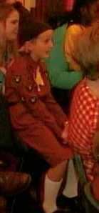
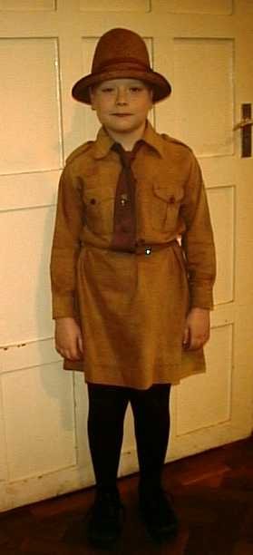

⬅1920s Brownie
⬅1970s Brownie
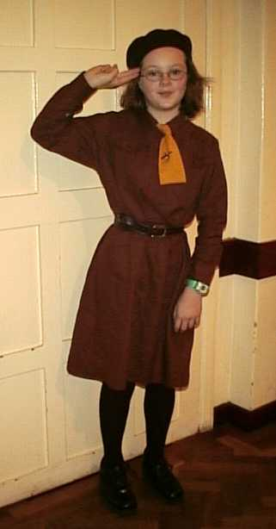

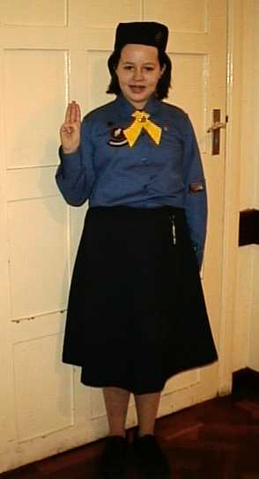

⬅1950s Brownie
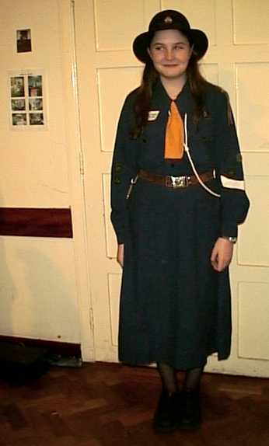
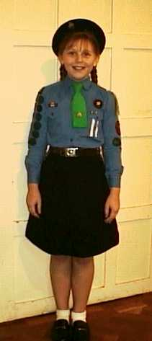
1920s ➔
Guide
1950s Guide➔

⬆
1970s Guide

In the afternoon we held a party for past and present Brownies and Leaders. One ex-Guider came down specially from Yorkshire.

We entertained our guests with a concert of music, poetry and a short play.
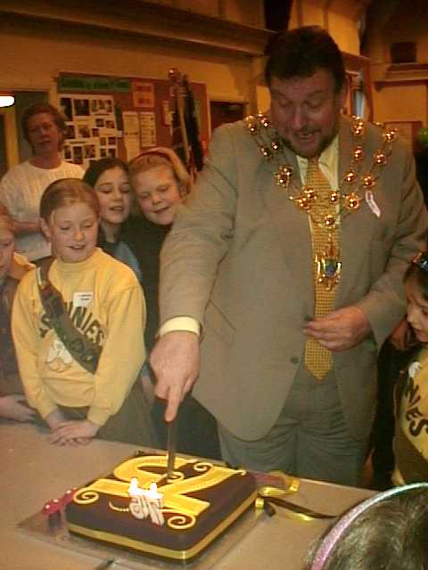
The Mayor and Mayoress joined us too. He read us his favourite poem and then cut our birthday cake.

